**🡸---------------OFFICE STAFF MANAGEMENT SYSTEM-----------🡺**

**NAME : CHIRAG PATEL**

**ROLL NO : 173**

**BRANCH : CE**

**DIVISION : D6**

**ENROLLMENT NO : 22002170110107**

1. **GETTING EMPLOYEE PERSONAL DETAILS AND DESIGNATION DETAILS BY HIS/HER ID :**

CREATE OR REPLACE PROCEDURE GET_EMP_DEATILS_DESIGNATION1(IN_ID INT)AS

$$

DECLARE

CHECK_S INT;

O_ID EMPLOYEE.E_ID%TYPE;

FIRST EMPLOYEE.E_FIRSTNAME%TYPE;

LAST EMPLOYEE.E_LASTNAME%TYPE;

AGE EMPLOYEE.E_AGE%TYPE;

EMAIL EMPLOYEE.E_MAIL%TYPE;

NUMBER EMPLOYEE.E_NUMBER%TYPE;

DOB EMPLOYEE.E_DOB%TYPE;

DESIGN EMP_DESIGNATION.E_DESIGNATION%TYPE;

SALARY EMP_DESIGNATION.E_SALARY%TYPE;

JOINING EMP_DESIGNATION.E_JOININGDATE%TYPE;

PRECOM EMP_DESIGNATION.E_PREVIOUSCOMPANY%TYPE;

BEGIN

SELECT COUNT(E_ID) INTO CHECK_S FROM EMPLOYEE WHERE E_ID=IN_ID;

IF(CHECK_S>0) THEN

SELECT E_ID,E_FIRSTNAME,E_LASTNAME,E_AGE,E_MAIL,E_NUMBER,E_DOB INTO O_ID,FIRST,LAST,AGE,EMAIL,NUMBER,DOB FROM EMPLOYEE WHERE E_ID=IN_ID;

SELECT E_DESIGNATION,E_SALARY,E_JOININGDATE,E_PREVIOUSCOMPANY INTO DESIGN,SALARY,JOINING,PRECOM FROM EMP_DESIGNATION WHERE E_ID=IN_ID;

RAISE NOTICE 'EMPLOYEE ID : % EMPLOYEE NAME : % % ',O_ID,FIRST,LAST;

RAISE NOTICE 'EMPLOYEE AGE : % EPMPLOYEE EMAIL : % EMPLOYEE NUMBER : %',AGE,EMAIL,NUMBER;

RAISE NOTICE 'EMPLOYEE DOB : % EMPLOYEE DESIGANTION : % EMPLOYEE SALARY : % ',DOB,DESIGN,SALARY;

RAISE NOTICE 'EMPLOYEE JOIN DATE : % EMPLOYEE PREVIOUS COMPANY : % ',JOINING,PRECOM;

ELSE

RAISE NOTICE 'EMPLOYEE DOESNOT EXIST !';

END IF;

END;

$$

LANGUAGE PLPGSQL;

CALL GET_EMP_DEATILS_DESIGNATION1(1);

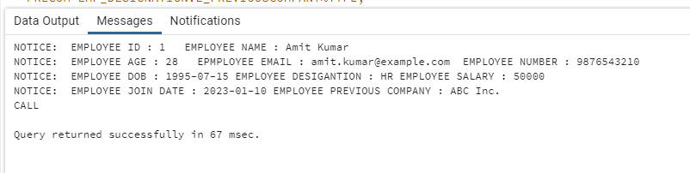

1. **GETTING ADMINS PERSONAL DETAILS AND DESIGNATION DETAILS BY HIS/HER ID :**

CREATE OR REPLACE PROCEDURE GET_ADM_DEATILS_DESIGNATION2(IN_ID INT)AS

$$

DECLARE

CHECK_S INT;

O_ID ADMINISTRATION.A_ID%TYPE;

FIRST ADMINISTRATION.A_FIRSTNAME%TYPE;

LAST ADMINISTRATION.A_LASTNAME%TYPE;

AGE ADMINISTRATION.A_AGE%TYPE;

EMAIL ADMINISTRATION.A_EMAIL%TYPE;

NUMBER ADMINISTRATION.A_NUMBER%TYPE;

DOB ADMINISTRATION.A_DOB%TYPE;

DESIGN ADMIN_DESIGNATION.A_DESIGNATION%TYPE;

SALARY ADMIN_DESIGNATION.A_SALARY%TYPE;

PREPOS ADMIN_DESIGNATION.A_PREVIOUSPOST%TYPE;

PRECOM ADMIN_DESIGNATION.A_PREVIOUSCOMPANY%TYPE;

BEGIN

SELECT COUNT(A_ID) INTO CHECK_S FROM ADMINISTRATION WHERE A_ID=IN_ID;

IF(CHECK_S>0) THEN

SELECT A_ID,A_FIRSTNAME,A_LASTNAME,A_AGE,A_EMAIL,A_NUMBER,A_DOB INTO O_ID,FIRST,LAST,AGE,EMAIL,NUMBER,DOB FROM ADMINISTRATION WHERE A_ID=IN_ID;

SELECT A_DESIGNATION,A_SALARY,A_PREVIOUSCOMPANY,A_PREVIOUSPOST INTO DESIGN,SALARY,PRECOM,PREPOS FROM ADMIN_DESIGNATION WHERE A_ID=IN_ID;

RAISE NOTICE 'ADMIN ID : % ADMIN NAME : % % ',O_ID,FIRST,LAST;

RAISE NOTICE 'ADMIN AGE : % ADMIN EMAIL : % ADMIN NUMBER : %',AGE,EMAIL,NUMBER;

RAISE NOTICE 'ADMIN DOB : % ADMIN DESIGANTION : % ADMIN SALARY : % ',DOB,DESIGN,SALARY;

RAISE NOTICE ' ADMIN PREVIOUS COMPANY : % ADMIN PREVIOUS POST : % ',PRECOM,PREPOS;

ELSE

RAISE NOTICE 'ADMIN DOESNOT EXIST !';

END IF;

END;

$$

LANGUAGE PLPGSQL;

CALL GET_ADM_DEATILS_DESIGNATION2(20);

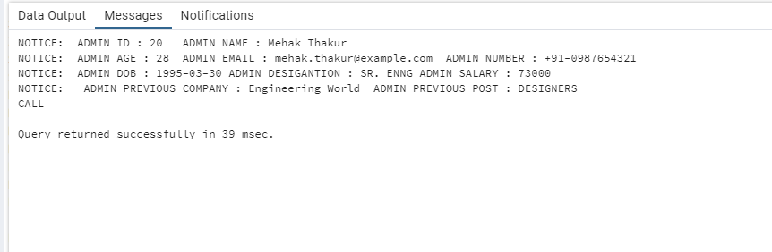

1. **GETTING MAX SALARY OF EMPLOYEE/ADMINISTARTION BY ENTERING DESIGNATION NAME :**

CREATE OR REPLACE FUNCTION GET_MAX_SALARY_BY_DESIGN(DESIGNATION VARCHAR(20)) RETURNS INT AS

$$

DECLARE

MAX_SALARY INT;

BEGIN

SELECT MAX(E_SALARY) INTO MAX_SALARY FROM EMP_DESIGNATION WHERE E_DESIGNATION=DESIGNATION;

RETURN MAX_SALARY;

END;

$$

LANGUAGE PLPGSQL;

SELECT GET_MAX_SALARY_BY_DESIGN('MARKETING');

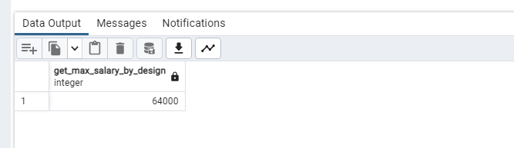

1. **GETTING ADMINISTRATIONS LIST BY DESIGNATION:**

CREATE OR REPLACE PROCEDURE GET_ADMININTRATIONS_BY_DESIGNATION(IN_D VARCHAR(30)) AS

$$

DECLARE

FIRST ADMINISTRATION.A_FIRSTNAME%TYPE;

LAST ADMINISTRATION.A_LASTNAME%TYPE;

DESIGN ADMIN_DESIGNATION.A_DESIGNATION%TYPE;

SALARY ADMIN_DESIGNATION.A_SALARY%TYPE;

C1 CURSOR FOR SELECT ADMINISTRATION.A_FIRSTNAME,ADMINISTRATION.A_LASTNAME,ADMIN_DESIGNATION.A_DESIGNATION,

ADMIN_DESIGNATION.A_SALARY FROM ADMIN_DESIGNATION INNER JOIN ADMINISTRATION

ON ADMINISTRATION.A_ID=ADMIN_DESIGNATION.A_ID WHERE A_DESIGNATION=IN_D;

BEGIN

OPEN C1;

LOOP

FETCH C1 INTO FIRST,LAST,DESIGN,SALARY;

EXIT WHEN NOT FOUND;

RAISE NOTICE 'ADMINISTRATION NAME: % %

ADMINISTRAION DESIGNATION : %

ADMINISTRATION SALARY : % ',FIRST,LAST,DESIGN,SALARY;

END LOOP;

CLOSE C1;

END;

$$

LANGUAGE PLPGSQL;

-- CALL GET_ADMININTRATIONS_BY_DESIGNATION('HOD');

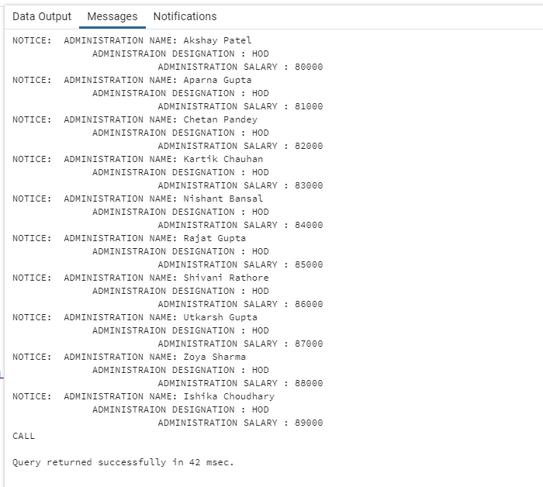

1. **TRIIGERS ON INSERTION WHEN OLD ID IS INSETRED AGAIN OR NEGATIVE ID IS INSERTED IN TABLE :**

CREATE OR REPLACE FUNCTION CHECK_E_ID()returns trigger as

$$

DECLARE

CHECK_E INT;

BEGIN

SELECT COUNT(*) INTO CHECK_E FROM EMPLOYEE WHERE E_ID=NEW.E_ID;

IF NEW.E_ID <0 THEN

RAISE 'LESSS THAN ZERO VALUE NOT ALLOWED';

ELSE

IF CHECK_E >0 THEN

RAISE 'THAT ID ALREAFDY EXIST !';

END IF;

END IF;

RETURN NEW;

END;

$$

LANGUAGE PLPGSQL;

CREATE TRIGGER CHECK_E_ID

BEFORE INSERT ON EMPLOYEE

FOR EACH ROW

EXECUTE PROCEDURE CHECK_E_ID();

INSERT INTO employee (E_ID, E_FIRSTNAME, E_LASTNAME, E_AGE, E_MAIL, E_NUMBER, E_DOB)

VALUES

(-1, 'Amit', 'Kumar', 28, 'amit.kumar@example.com', '9876543210', '1995-07-15');

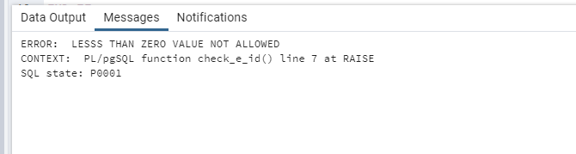

1. **GETTING EMPLOYEES AND ADMINS BY ENTERING DEPARTAMENT NAME :**

CREATE OR REPLACE PROCEDURE GET_EMP_ADM_BY_DEPT(DEPART VARCHAR(20)) AS

$$

DECLARE

FIRST_E EMPLOYEE.E_FIRSTNAME%TYPE;

LAST_E EMPLOYEE.E_LASTNAME%TYPE;

FIRST_A ADMINISTRATION.A_FIRSTNAME%TYPE;

LAST_A ADMINISTRATION.A_LASTNAME%TYPE;

C1 CURSOR FOR SELECT EMPLOYEE.E_FIRSTNAME,EMPLOYEE.E_LASTNAME FROM EMPLOYEE INNER JOIN DEPARTMENT

ON EMPLOYEE.E_ID=DEPARTMENT.E_ID WHERE D_NAME=DEPART;

C2 CURSOR FOR SELECT ADMINISTRATION.A_FIRSTNAME,ADMINISTRATION.A_LASTNAME FROM ADMINISTRATION INNER JOIN DEPARTMENT

ON ADMINISTRATION.A_ID=DEPARTMENT.A_ID WHERE D_NAME=DEPART;

BEGIN

OPEN C1;

OPEN C2;

LOOP

FETCH C1 INTO FIRST_E,LAST_E;

EXIT WHEN NOT FOUND;

RAISE NOTICE 'EMPLOYEEE LIST : % % ',FIRST_E,LAST_E;

END LOOP;

LOOP

FETCH C2 INTO FIRST_A,LAST_A;

EXIT WHEN NOT FOUND;

RAISE NOTICE 'ADMIN LIST : % % ',FIRST_A,LAST_A;

END LOOP;

CLOSE C2;

CLOSE C1;

END;

$$

LANGUAGE PLPGSQL;

-- CALL GET_EMP_ADM_BY_DEPT('ACCOUNTS');

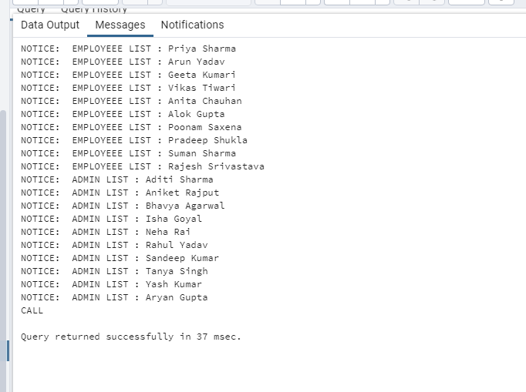

1. **ENTER THE SALARY AND INCREMENT PERECENATGE AND QUERY WILL INCREMENTS ALL EMPLOYEE'S SALARY WHO IS LESS THAN ENTERED SLARY :**

CREATE OR REPLACE PROCEDURE UPDATE_SALARY1(I_SALARY INT, INCR INT) AS

$$

DECLARE

INCREMENTED INT;

NEW_SAL INT;

FIRST ADMINISTRATION.A_FIRSTNAME%TYPE;

LAST ADMINISTRATION.A_LASTNAME%TYPE;

DESIGN ADMIN_DESIGNATION.A_DESIGNATION%TYPE;

SALARY ADMIN_DESIGNATION.A_SALARY%TYPE;

C1 CURSOR FOR SELECT ADMINISTRATION.A_FIRSTNAME, ADMINISTRATION.A_LASTNAME, ADMIN_DESIGNATION.A_DESIGNATION, ADMIN_DESIGNATION.A_SALARY

FROM ADMIN_DESIGNATION

INNER JOIN ADMINISTRATION ON ADMINISTRATION.A_ID = ADMIN_DESIGNATION.A_ID

WHERE A_SALARY > I_SALARY;

BEGIN

INCREMENTED := INCR / 100;

OPEN C1;

LOOP

FETCH C1 INTO FIRST, LAST, DESIGN, SALARY;

EXIT WHEN NOT FOUND;

RAISE NOTICE 'ADMIN NAME : % %', FIRST, LAST;

RAISE NOTICE 'ADMIN OLD SALARY : %', SALARY;

NEW_SAL := SALARY + (INCREMENTED * SALARY);

RAISE NOTICE 'ADMIN NEW SALARY : %', NEW_SAL;

-- Update the salary in the ADMIN_DESIGNATION table

-- UPDATE ADMIN_DESIGNATION

-- SET A_SALARY = NEW_SAL

-- WHERE CURRENT OF C1;

END LOOP;

CLOSE C1;

-- Commit the changes to the database

COMMIT;

END;

$$

LANGUAGE PLPGSQL;

-- CALL UPDATE_SALARY1(50000,10);

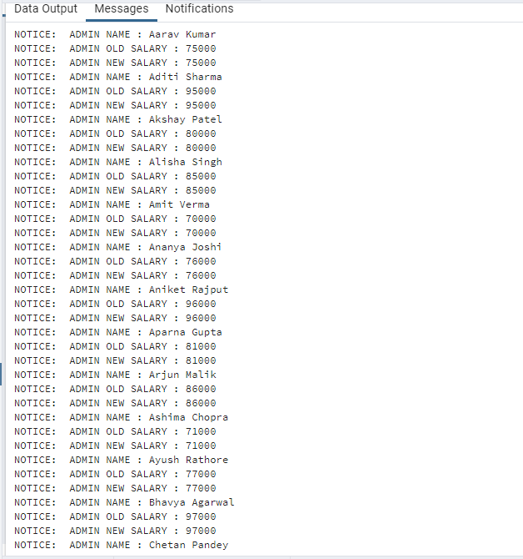

1. **GET HOW MANY NUMBERS OF EMPLOYEES :**

CREATE OR REPLACE FUNCTION GET_EMPLOYEE_COUNT_BY_DESIGNATION(DESIGN VARCHAR(30)) RETURNS INT AS

$$

DECLARE

COUNTER INT;

BEGIN

SELECT COUNT(E_ID) INTO COUNTER FROM EMP_DESIGNATION WHERE E_DESIGNATION=DESIGN;

RETURN COUNTER;

END;

$$

LANGUAGE PLPGSQL;

SELECT GET_EMPLOYEE_COUNT_BY_DESIGNATION('MARKETING');

